**Personalized invitation using Canva**

**Introduction:**

Welcome to the world of personalized invitations, where your special occasions come to life with a touch of uniqueness and charm. At [Your Company Name], we understand the importance of celebrating life's milestones in style. That's why we offer a wide range of beautifully designed, customizable invitations that capture your personal flair and set the tone for your event.

**Problem and design thinking:**

**EMPATHY MAP**

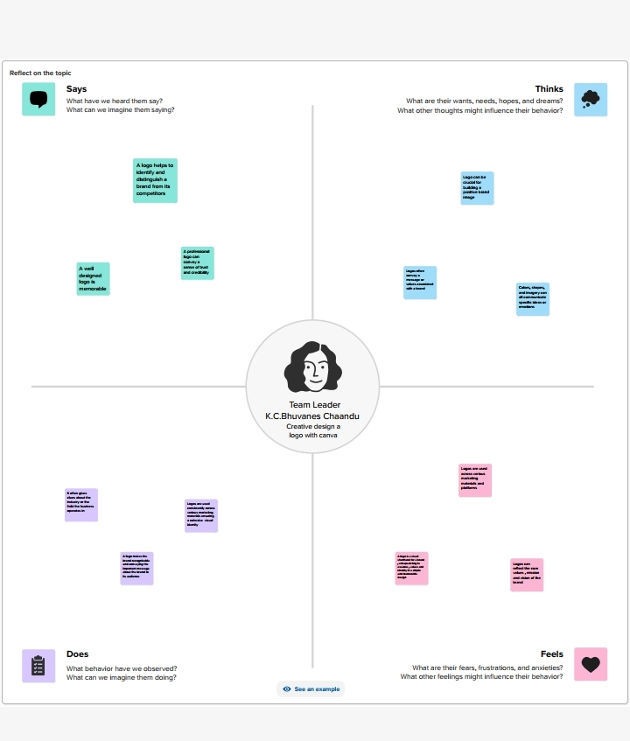

**BRAINSTORMING MAP**

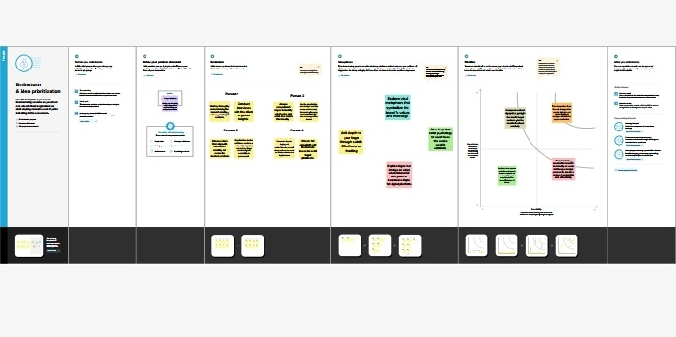

**Result:**



**Advantages and disadvantages:**

**Advantages:**

**Uniqueness: Personalized invitations allow you to create a design that is tailored specifically to your event and reflects your individual style and personality. This helps set your event apart and makes it more memorable for your guests.**

**Disadvantages:**

**Time and Effort: Creating personalized invitations can be time-consuming, especially if you’re designing them from scratch. It requires careful consideration of design elements and customization options. Additionally, if you have a large guest list, the process can become more demanding.**

**Applications:**

**There are several applications available that you can use for designing a invitations. Here are a few popular ones:**

**Canva: Canva offers a user-friendly interface with a wide range of templates, fonts, and graphics to create a invitation . It also provides customization options and the ability to export your invitation in various formats.**

**Conclusion:**

**Conceptualization: Generate ideas and concepts based on the research. This involves brainstorming, sketching, and exploring different visual elements that represent the brand effectively.**